https://github.com/JhanaR/pre-req.git
JAVASCRIPT
What is JavaScript and its purpose?
High level Programming interpreted language primarily used to create interactive and dynamic content on UI.
Purpose of JavaScript:
Client-Side Scripting: JavaScript is mainly used for client-side development, it runs in the user's web browser without the need for server-side processing.
DOM Manipulation: JavaScript can interact with the Document Object Model (DOM), enabling developers to modify the content and structure of web pages dynamically.
Event Handling: JavaScript allows developers to respond to user interactions such as clicks, key presses, or form submissions, making web pages more interactive.
Form Validation: JavaScript can validate user input in forms before submitting data to the server
Asynchronous Operations: JavaScript supports asynchronous programming through techniques like callbacks, promises, and async/await.
Web APIs Integration: JavaScript can interact with various web APIs (e.g., Geolocation API, Fetch API, Web Storage API, DOM API) to enhance functionality, such as retrieving data from a server, storing data locally, or accessing the user’s location.
Cross-Platform Development: With environments like Node.js, JavaScript can also be used for server-side development, enabling the creation of full-stack applications. It's also used in mobile app development (e.g., React Native) and desktop applications (e.g., Electron).
Explain what kind of application we can built using Javascript.
variety of applications across different platforms.
Web Application
Mobile Application
Desktop Applications etc
What is .classList in JavaScript?
.classList is a JavaScript property used to access the list of CSS classes assigned to an HTML element. It provides methods to add, remove, toggle, or check classes on that element.
What are variables and explain the rules to create a variable?
Variables in JavaScript are used to store data that can be referenced and manipulated within a program.
Rules to follow while making use of variables
Variable name should contain only letter,digits,symbols($) and (_)underscore
First character must not be the digits
Variable Names should be in camelCase
What are Data types ?
Data types define the kind of data that can be stored and manipulated within a program.
Primitive Data Types:
Non-Primitive Data Types
Explain Primitive and Non-Primitive Data type.
JavaScript has 7 primitive types like.
Data Types: String, Number, Boolean, Undefined, Null, Symbol, BigInt which hold a single value and are immutable.
Non-Primitive(Reference) types like arrays and objects store more complex data structures and are passed by reference.
I often use typeof and Array.isArray() to safely check types before operations.
What is difference between let , cons and var
In JavaScript, var, let, and const are used to declare variables, but they differ in terms of
, hoisting, and reassignment or mutability.
🔹 Hoisting:
Hoisting is the mechanism where variable and function declarations are moved to the top of their nearest scope during the compilation phase.
If we try to access a variable declared with var before it's assigned, it will return undefined but won’t throw an error.
In contrast, accessing variables declared with let or const before initialization will throw a ReferenceError.
🔹 Scope:
var is function-scoped
let and const are block-scoped
🔹 Reassignment & Redeclaration:
var: Allows reassignment and redeclaration
let: Allows reassignment, but not redeclaration in the same scope
const: Neither reassignment nor redeclaration is allowed
In my projects, I avoid var completely. I use let for values that change (like counters), and const for everything else — especially functions and objects.
HOISTING:
Hoisting is JavaScript's behaviour of moving variable and function declarations to the top of their scope during the compilation phase.
Only the declarations are hoisted — not the initializations.
Example
Var | Let | Const
console.log(a); | HOISTING will not support
var a = 10;
Internally var a;
console.log(a);
//nearest scope a = 10 ;
SCOPE/Memory var is a function level scope | let/const are block level scope { }
var supports redeclaration and Updation | let supports only Updation | with const no redeclaration /Updation, it must declare while initialize

- var is function-scoped and allows hoisting but is prone to bugs due to re-declaration.
- let is block-scoped and prevents re-declaration.
- const is also block-scoped, and its value cannot be reassigned. However, objects declared with const can still have their properties modified.
What is the difference between Function Scope and Block Scope in JavaScript?
var → Function Scoped
A var variable is accessible anywhere inside the function where it is declared, even before its declaration (due to hoisting).
function testVar() {
if (true) {
var a = 10;
}
console.log(a); // Works (function scoped)
}
testVar();

let & const → Block Scoped
let and const are limited to the block (anything between { }) in which they are declared.

function testLet() {
if (true) {
let b = 20;
const c = 30;
}
console.log(b); // ReferenceError
console.log(c); // ReferenceError
}
testLet();

What is spread operator
Getting new array with the existing array values but not same array.
the spread operator is used to expand elements from an array or object into individual elements - useful when copying, merging, or passing values.
- Used to copy, combine, or pass elements individually.
- Works on iterables (arrays, strings) and objects.
Expands values out
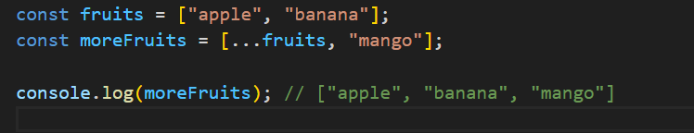

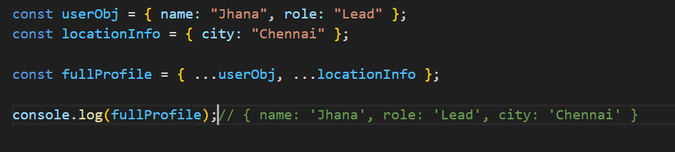

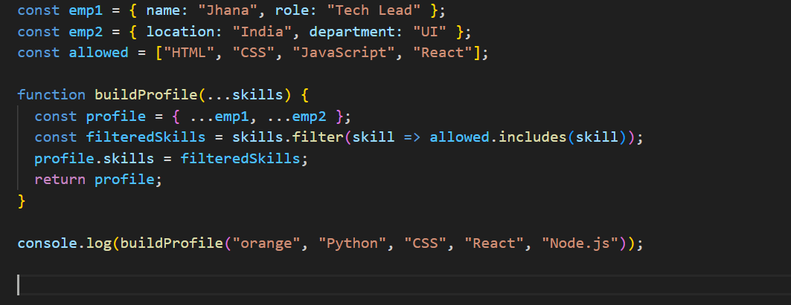
What is Rest Parameter
Rest parameter is used in function definitions to gather multiple arguments into an array, whereas
Gathers values into one
- Used in function parameters and destructuring.
- Opposite of spread — it bundles values together.
What is function in JavaScript?
Reusable block of code designed to perform a specific task. Functions allow you to encapsulate logic and avoid code repetition
Explain function and different types of function in Javascript
functions are the building blocks
Allow not to repeat the code
Difference between Function Declaration and Function Expression
Function declarations are hoisted and can be called before they are defined, while function expressions are not hoisted and must be defined before they are called.
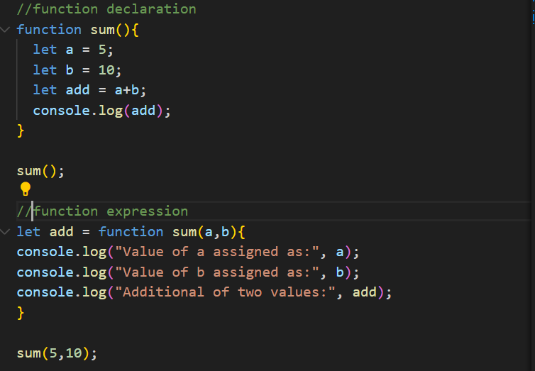
What is an anonymous function in JavaScript?
An anonymous function is a function without a name. It can be assigned to a variable or passed as an argument to another function. They are often used for onetime or callback functions.
What is the purpose of the filter() function in JavaScript?
The filter() function is used to create a new array containing elements that pass a certain condition defined by a provided function. It allows filtering elements from an array based on specific criteria.
What is the purpose of the reduce() function in JavaScript?
The reduce() function is used to reduce an array to a single value by applying a function to each element and accumulating
What is arrow function in Javascript
Arrow functions are useful for creating short and readable functions, A concise way to write function expressions
Syntax: (parameters) => { body }
Arrow functions do not have their own this.
They inherit this from the lexical scope where they were defined (i.e., the surrounding context).
In this case, the arrow function is defined in the global scope, so this === window in browser or undefined (in strict mode / Node).
So, this.name is undefined.
How many ways can a function be invoked?
In JavaScript, functions can be invoked in several ways: as a regular function, as a method of an object, as a constructor using new, indirectly using call or apply, by binding with bind, as an arrow function (which uses lexical this), or immediately as an IIFE. Each style of invocation changes how this is determined.
Why we use call, apply bind method in
call: Invokes the function immediately with a specified this and arguments.
apply: Invokes the function immediately with a specified this and an array of arguments.
bind: Creates a new function with a specified this and optional pre-filled arguments, to be invoked later.
What is the array method , string method
In JavaScript, array and string methods are built-in functions that allow us to manipulate and process arrays and strings efficiently.
Array Methods
Used to perform operations like adding, removing, or transforming elements in an array.
Common examples:
map() – The map() method is used to transform each element of an array and return a new array with the transformed values.It never mutates the original array
filter() – filters elements based on condition, returns all matching elements as a new array.
reduce() – reduces the array to a single value
push() / pop() – add/remove from the end
includes() – checks if a value exists
“I commonly use map, filter, and reduce in React for rendering and data transformation.”
String Methods
Used for manipulating and analyzing text.
Common examples:
split() – converts a string to array
slice() – extracts part of a string
toUpperCase() / toLowerCase() – changes case
replace() – replaces part of a string
trim() – removes whitespace
find() – returns the first matching elemen
“I often use trim() to clean input, and split() when handling CSV data or form values.”
What is the purpose of the array slice method?
What is the purpose of the array splice method?
What is the difference between slice and splice?
What is the difference between map and filter and reduce?
What does new keyword do?
In JavaScript, the new keyword is used to create instances from a constructor function or class. It internally creates a new empty object, links it to the constructor’s prototype, binds this to that object, and returns the object. This allows us to reuse constructor functions or classes to build multiple similar objects.
What are lambda expressions or arrow functions?
What is a first class function? Or What is a first order function?
What is a unary function?
What is the currying function?
What is a pure function?
What are the benefits of pure functions?
What is Null and undefined and NaN in javascript.
In JavaScript, both null and undefined represent the absence of a value
undefined is a primitive value that indicates that a variable has been declared but not yet assigned a value.
null is a primitive value that represents the intentional absence of any object value. a variable should have no value or that an object reference is empty.
in javascript null means "reference to non-existing object "
typeof null → "object"
typeof undefined → "undefined"
(typeof NaN); // "number"
NaN: "Not a Number" — result of invalid math operation
Why is type of null === "object"?
typeof null returns 'object' due to a legacy bug in JavaScript’s implementation. Although null is a primitive, it's incorrectly tagged as an object in memory. To truly check for null, we should use a strict comparison like value === null.
What are the possible ways to create Array in JavaScript?
1.let arr = [“a”,1,true,{name: jahna”}]
2.Let arr = new Array (“a”,1,true,{name: jahna”}
3.let arr = Array.of("a", 1, true, { name: "jahna" });
4.let arr = Array.from("hello"); // ['h', 'e', 'l', 'l', 'o']
5. let str = "hello";
let arr = [...str]; // ['h', 'e', 'l', 'l', 'o']
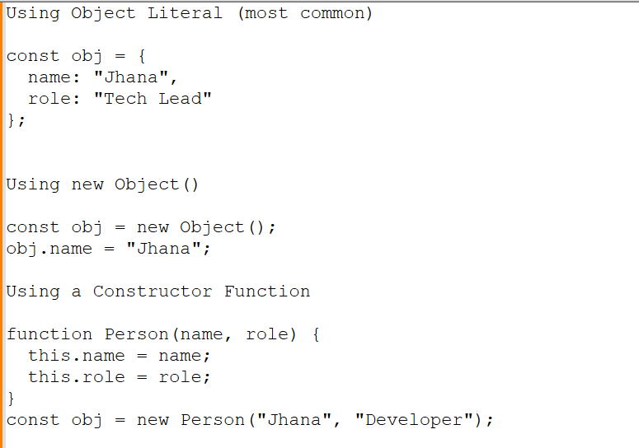
What are the different ways to clone an object Explain deep vs shallow copy?
Shallow Copy: Only copies the top-level properties. If a nested object exists, it still refers to the same memory so it's copied by reference.
Object.assign({}, obj)
Spread syntax: { ...obj }
array.slice() or array.from
let item = {
name: 'laptop',
price: 33000,
quantity: 1,
category: ['electronics', 'laptop']
dimensions: {
length: 7,
breadth: 3.5,
}
};
const spread = { ...item }; // Shallow copy
spread.quantity = 88; // Primitive value — copied safely
spread.dimensions.breadth = 22; // Nested object — shared reference!
spread.quantity is a primitive value, so it's copied by value.
spread.dimensions is a nested object, so it's copied by reference.
Deep Copy: it won’t disturb the original one.
JSON.parse(JSON.stringify())
structuredClone(obj) (modern, recommended)
Recursion or using libraries like lodash.cloneDeep
const deepClone = JSON.parse(JSON.stringify(item));
deepClone.dimensions.breadth = 99;
console.log('deepClone breadth', deepClone.dimensions.breadth); // 99
console.log('item breadth', item.dimensions.breadth); // 22 (unchanged)
How do you compare Object and Map ?
What is optional chaining?
What is the difference between map and forEach functions?
How to invoke an IIFE without any extra brackets?
What are truthy and falsy values?
Falsy values: false, 0, "", null, undefined, NaN
Everything else is truthy.
Lexical Scope (used by JavaScript)?
Lexical scope means a function can access variables or variable’s visibility from the scope where it was defined, not where it's called.
Inner functions access variables from their outer (parent) scopes.
What is closure in Javascript?
A closure is a function that remembers its lexical scope even when the function is executed outside that scope.
In simpler terms:
A function accessing variables from its parent (outer) function, even after the parent has finished executing.
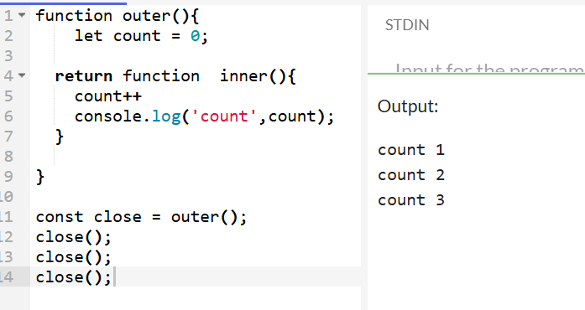
outer() has finished executing, the returned inner function still remembers count. That’s a closure.
What is the difference between array and object
Arrays and Objects are both used to store collections of data, but they differ in structure, purpose, and how you access their data.
Array
Stores ordered list of values.
Indexed using numeric keys (starting from 0).
Commonly used for lists, collections, sequences.
Has built-in methods like .map(), .filter(), .push(), etc.
Object
Stores unordered data as key-value pairs.
Keys are strings (or Symbols), not numbers.
Used to represent entities or structured data.
How delete Works
- Deletes object properties: Removes the property completely from the object.
- Cannot delete local or global variables: Variables declared with var, let, or const are not deleted by delete.
- Returns true if deletion is successful or property doesn't exist, else false.
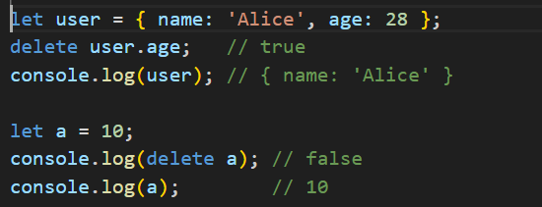
How to make an array empty?
By making the array length = 0; or assigning empty array;
Ler arr = [1,2,3,4]
arr.length = 0 or arr = [];
What is the difference between number type and BigInt type
Both Number and BigInt are used to represent numeric values, but they differ in size limits and precision.
DOM
The Document Object Model (DOM) is a programming interface that represents the structure of HTML and XML documents. It allows JavaScript to access and manipulate the content and structure of a webpage.
DOM Manipulation
JavaScript can interact with the Document Object Model (DOM), enabling developers to modify the content and structure of web pages dynamically.
How to create element dynamically using Javascript
can use document.createElement() to create a new HTML element and append() to insert it into the DOM."
Difference between Normal Function and Arrow Function
A regular function has its own this context, which is dynamically bound based on how the function is called. It also supports hoisting, can access the arguments object, and can be used as a constructor with new.
On the other hand, an arrow function is more concise and inherits this from its enclosing (lexical) scope. It doesn’t support hoisting, doesn’t have its own this or arguments, and cannot be used as a constructor.
Syntax
Regular: function greet() { }
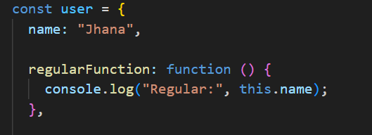
When you call it like user.regularFunction(), the this refers to the user object
So: this.name → "Jhana"
Arrow: const greet = () => { }
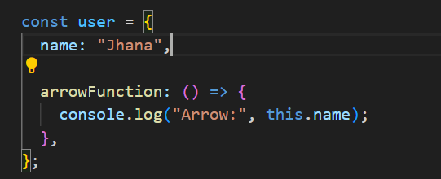
Arrow functions do not have their own this
So: this.name → undefined
Hoisting
Regular functions are hoisted — you can call them before their definition.
Arrow functions are not hoisted — you must define them before using them.
What is the difference between call(),apply() and bind()
Both call() and apply() are used to invoke a function with a specific this context. The only difference is how arguments are passed.
Call(): Invokes a function immediately, with a specified this and arguments passed individually.
func.call(thisArg, arg1, arg2, ...);
apply():Same as call(), but arguments are passed as an array. (or array-like object).
func.apply(thisArg, [arg1, arg2, ...]);
bind()
Does NOT invoke the function immediately.
Returns a new function with this permanently bound.
Used for delayed or reusable function execution.
const boundFunc = func.bind(thisArg, arg1, arg2);
boundFunc(); // later
The call(), apply(), and bind() methods allow you to control the value of this inside a function. call() and apply() execute the function immediately with arguments passed either individually or as an array. bind() returns a new function with this bound, ideal for delayed execution or event binding.
What is JSON and Its Common Operations?
JSON (JavaScript Object Notation) is a lightweight data-interchange format used to store and transport data. It is:
Easy to read and write for humans
Easy to parse and generate for machines
Language-independent (though based on JavaScript syntax)
JSON is commonly used in:
APIs (sending/receiving data)
Config files
Storing structured data (e.g., localStorage)
What is DOM and DOM Manipulation.?
What design patterns do you commonly use in JavaScript projects?
- Module Pattern: To encapsulate and organize code.
- Observer Pattern: For event-driven architecture or pub/sub systems.
- Factory Pattern: For object creation with dynamic behavior.
- Singleton Pattern: For managing global state like auth/session.
- I also follow SOLID principles in my component and service design.

What is import and export?
The import and export keywords are used in JavaScript ES6 modules to share code between files — making code modular, reusable, and easier to maintain.
What is Destructing in the Javascript
Destructuring is a feature in JavaScript that lets you unpack values from arrays or properties from objects into individual variables in a clean and readable way.
Destructuring makes your code cleaner and more readable by directly extracting values from arrays or objects. It’s especially useful in modern JavaScript, React, and API response handling.
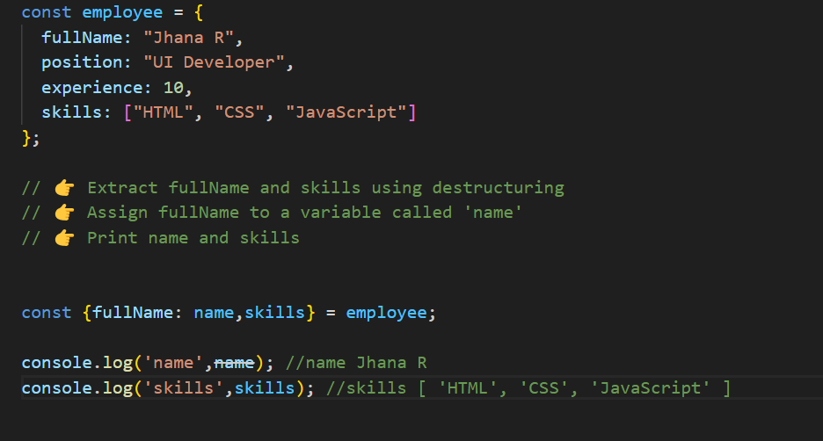
Explain difference between map() and forEach()
Use map() when you need to create a new array by applying a transformation to each element of the original array.
Use forEach() when you need to execute a function for each element of the array without modifying or creating a new array.
map() and forEach() are both methods used to iterate over arrays
forEach | Map
Does not return a new array | Returns a new array with the transformed elements
Since forEach() returns undefined, it cannot be chained with other array methods. | Since map() returns a new array, it can be chained with other array methods like filter(), reduce(), etc.

What are events in Javascript.
Events are actions or occurrences that happen in the browser, can respond to these events by executing code in response.
Mouse Events
Keyboard Events
Form Events etc.
What are is map, filter , reducer in javascript?
They are powerful higher-order array methods introduced in ES5, commonly used for data transformation in a clean and functional way.
Map: Transforms each element and returns a new array.
filter(): Filters elements based on a condition and returns a new array.
Reducer: Reduces array to a single value by iterating and accumulating.
Explain Closures in Javascript ?
Closures are functions which is created when an inner function captures variables from its parent function’s scope.
Even after the parent function has returned, the inner function still retains access to those variable
function createCounter() {
let count = 0; // outer variable
return function() { // inner function (closure)
count++;
return count;
};
}
const counter1 = createCounter();
console.log(counter1()); // 1
console.log(counter1()); // 2
console.log(counter1()); // 3
What are the uses of closures?
Explain different Scopes in Javascript?
Function level
Any variables, functions or class is declared under a block
Global level:
Any variables, functions or class is not declared under any block
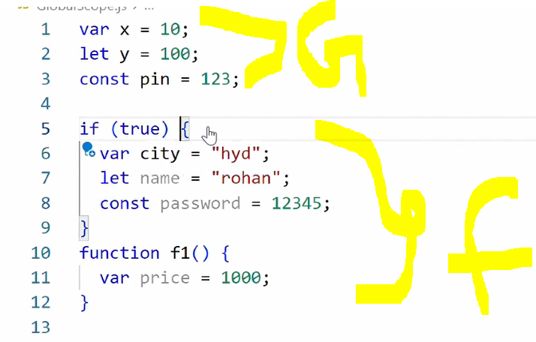
Module level:
Area across your application is considered as a module scope.
Any variables, functions or class is accessible from one file to another file using Named export and default Export.
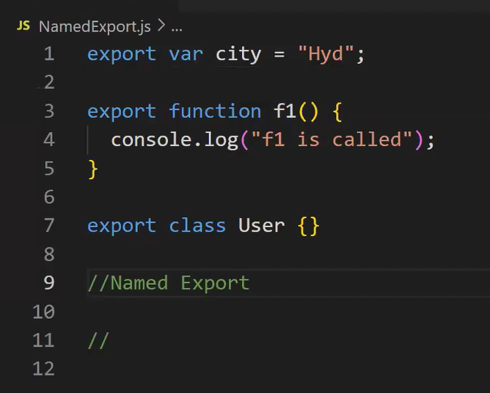
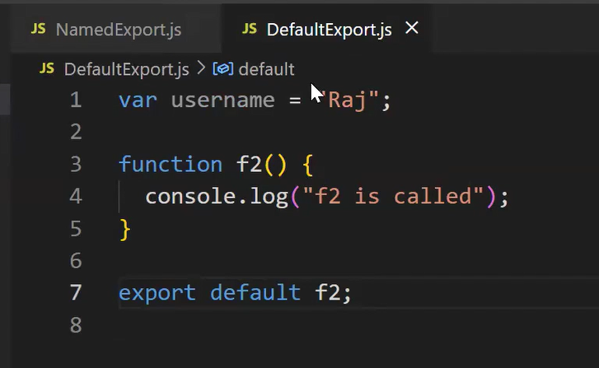
Can you explain how JavaScript handles asynchronous operations and how the event loop works in detail? Give a real-world example.
JavaScript is single-threaded, meaning it executes one task at a time using a single Call Stack.
However, it achieves asynchronous, non-blocking behaviour by offloading tasks to Web APIs and managing them through the Event Loop, which uses two main queues:
- Microtask Queue
- Macrotask Queue (Callback Queue)
The Event Loop prioritizes microtasks over macrotasks, ensuring promise resolutions and small tasks execute quickly before timers or I/O callbacks.
Event Loop:
- The Event Loop continuously monitors and coordinates between these queues and the Call Stack.
- Its core algorithm:
JS Code → Call Stack
↓
If async (setTimeout, fetch) → Sent to Web APIs
↓
Web API done? → Place callback into:
↳ Microtask Queue (Promises, async/await)
↳ Macrotask Queue (setTimeout, events)

Call Stack:
- Follows LIFO (Last In, First Out) order.
- Whenever a function is invoked, it’s pushed onto the stack; when execution completes, it’s popped off.
Web APIs:
- These are provided by the browser environment (not part of JavaScript itself).
- They handle asynchronous tasks such as:
- setTimeout, setInterval
- fetch or XMLHttpRequest
- DOM events
- Fetch()
- Local storage, console, location
- While these operations run in the background, the Call Stack continues executing other code.
Callback Queue (Macrotask Queue):
- When an async operation (like setTimeout) completes, its callback is placed into the Callback Queue (also known as Macrotask Queue).
- Examples of macrotasks:
- setTimeout, setInterval, I/O events, DOM event callbacks
- The Event Loop picks tasks from this queue only after all microtasks are completed.
Microtask Queue:
- Holds tasks that need to be executed immediately after the current stack is empty, before any macrotask.
- Common microtasks:
- Promise.then(), Promise.catch(), queueMicrotask(), MutationObserver
- Higher priority than macrotasks — all microtasks are processed before moving to the next macrotask.
Event Loop: Constantly checks if the call stack is empty. If empty:
  - First it processes all microtasks
  - Then it processes one macrotask from the callback queue
console.log("Start"); ---CallStack1
setTimeout(() => {
console.log("setTimeout"); MacroTask1
}, 0); ---
async function asyncFunc() {
console.log("Inside asyncFunc start"); --- CallStack2 result
await Promise.resolve();
console.log("Inside asyncFunc end");--- MicroTask1
}
asyncFunc(); --- CallStack2

Promise.resolve().then(() => {
console.log("Promise then");--- MicroTask2
});
console.log("End");--- CallStack3
Example:
How do you manage asynchronous operations in large-scale JavaScript apps?
I use Promises and async/await for readable async logic. For large-scale apps:
- I organize API calls in separate services/modules.
- I use error boundaries and global error handling.
What is currying in JavaScript? How is it different from partial application? Show an example and a real-time use case where currying might be helpful?
Currying is the process of transforming a function with multiple arguments into a sequence of functions, each taking one argument at a time.
Breaks a function into a chain of functions, each taking one argument.
What is Callback
A callback is a function that is passed as an argument to another function to be "called back" at a later time(exception, deadlock, successful)
What is higher order function in Javascript
Higher-Order Function: A function that either accepts functions as arguments or returns a function.
Accepting Functions: Allows customization and flexibility by passing functions as arguments.
Returning Functions: Enables dynamic creation of functions with specialized behavior.
Higher-order functions enhance code modularity, readability, and reusability, making them an essential concept in modern JavaScript programming.
Explain the Difference between callback and higher order function in JS?
A callback function is a function that is passed as an argument to another function.
Callbacks are often used for asynchronous operations, like handling events, making API requests, or performing tasks after a delay.
callback function is executed after some operation has been completed.
A higher-order function is a function that either:
Takes one or more functions as arguments, or
Returns a function as its result.
What is promise in Javascript
JavaScript Promises help manage asynchronous code by allowing us to handle success and failure in a structured way. They improve readability and avoid callback hell. Promises have three states: pending, fulfilled, and rejected
Methods:
.then(): Handles fulfillment and optionally rejection.
.catch(): Handles rejection.
.finally(): Runs regardless of fulfillment or rejection.
Advanced Methods: Promise.all(), Promise.race(), Promise.allSettled(), Promise.any().
Promise.all(), Promise.race(), Promise.allSettled(), Promise.any()
must-know for handling multiple promises in parallel
Promise.all():If any promise rejects → .catch() is triggered immediately, all async tasks must succeed before continuing
Promise.race(): Resolves or rejects as soon as the first promise settles (resolves OR rejects).
Fastest result wins, whether resolved or rejected.
Promise.allSettled(): Waits for all promises to settle (either resolve or reject). Always resolves with a summary of results. When you want to know the result of every promise, regardless of success/failure
Promise.any(): Only fails if all promises fail.
Explain different States of Promise in Javascript
• States: Pending, Fulfilled, Rejected.
How to create a Promise
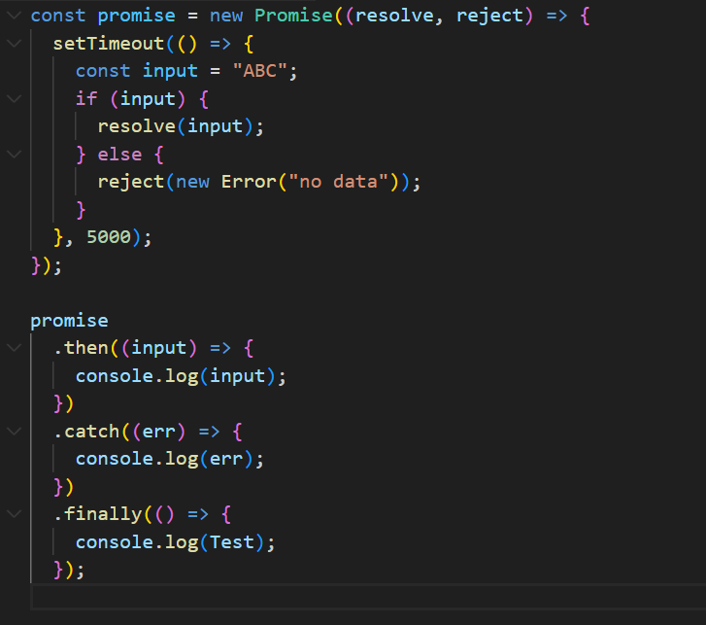
What is difference between promise and callback in Javascript
Callbacks: Functions passed to other functions to be executed later. Can lead to deeply nested code and complex error handling.
Promises: Objects that represent the completion of asynchronous operations. Provide better readability, chaining, and error handling.
Promises are generally preferred over callbacks for handling asynchronous operations due to their cleaner syntax, better error management, and improved composability.
What is Promise.all() in JavaScript, and how is it useful?
Promise.all() is a method that takes an array of Promises and returns a single Promise that:
Resolves when all of the input promises are resolved.
Rejects immediately if any one of the input promises is rejected.
What is Async and Await in Javascript
async and await make asynchronous JavaScript code look and behave more like synchronous code, improving readability and maintainability. They are built on top of Promises, providing a cleaner and more intuitive syntax for handling asynchronous operations.
When a function is declared with the async keyword, it automatically returns a Promise, regardless of whether you explicitly return one. Inside an async function, the await keyword pauses execution until the Promise it’s waiting for is settled (fulfilled or rejected). This allows developers to write asynchronous logic in a step-by-step, synchronous-like style without blocking the event loop.
Using try...catch with async/await simplifies error handling, as it works similarly to synchronous error handling rather than chaining .then() and .catch() methods. Additionally, async/await enables structured control over concurrency by allowing developers to decide when to run operations sequentially or in parallel using techniques like Promise.all().
- async functions always return a Promise.
- await pauses the function’s execution until the awaited Promise resolves or rejects.
- They enhance readability, simplify error handling, and offer better control over asynchronous flow without blocking the event loop.
What is setTimeOut and setInterval in Javascript
setTimeout()
Purpose: Executes a function once after a specified delay.
setTimeout(() => {
// code to run once
}, 1000); // 1000ms = 1 second
setInterval()
Purpose: Executes a function repeatedly at fixed time intervals.
setInterval(() => {
// code to run repeatedly
}, 1000); // every 1 second
What is a prototype chain?
What is this in JavaScript? Or
Explain "this" in different contexts (regular function, arrow function, method, setTimeout, etc.)
this refers to the object that is executing the current function.
In regular functions, this is dynamically scoped — it depends on how the function is called.
In arrow functions, this is lexically scoped — it doesn’t have its own this, but instead inherits it from the surrounding context where it was defined, not where it’s called.
Explain the difference between == and ====

Loose Equality Operator == Performs type coercion
Example: 2 == "2" results true
Strict Equality Operator === it doesn't support coercion (Checks both type and value)
Example: 2 === "2" results false
Double the values in an array.
To act upon each element of array and forms or returns a new array using map()
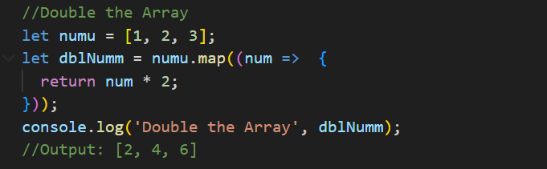
OR
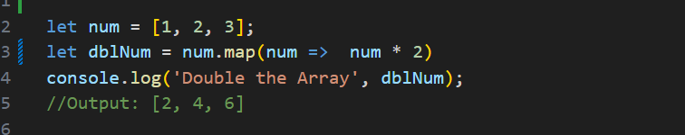
SPLICE and SLICE
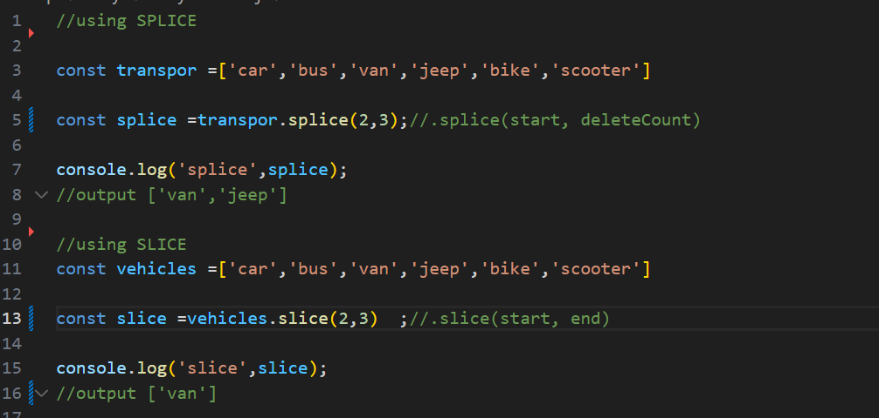
Filter out odd numbers or even numbers
Returns a new array with elements that match a condition
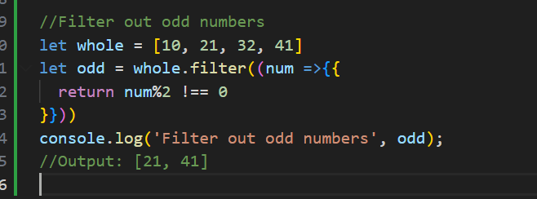
OR
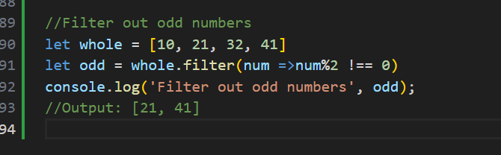
Check even and odd
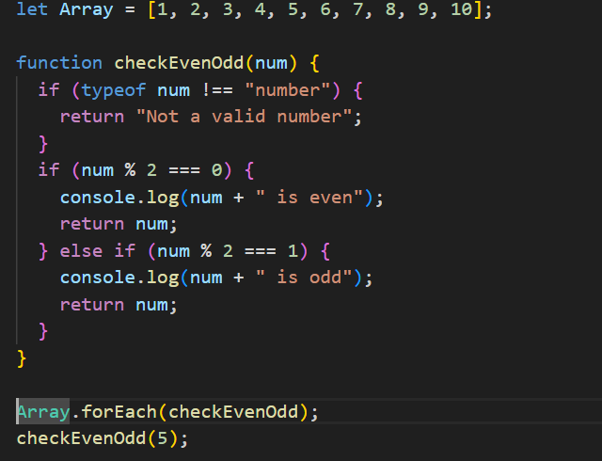
Find the largest/maximum number from a given array of numbers.
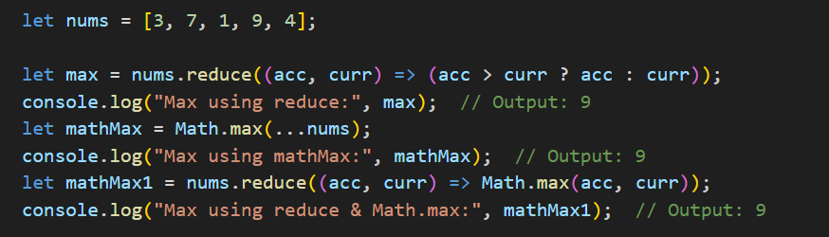
With loop function
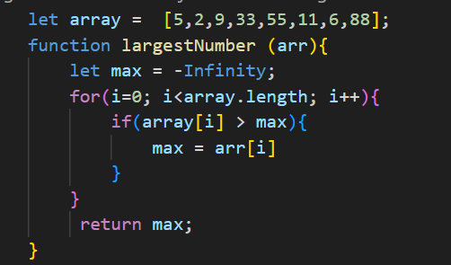
Find the second largest/second max number from array of numbers.
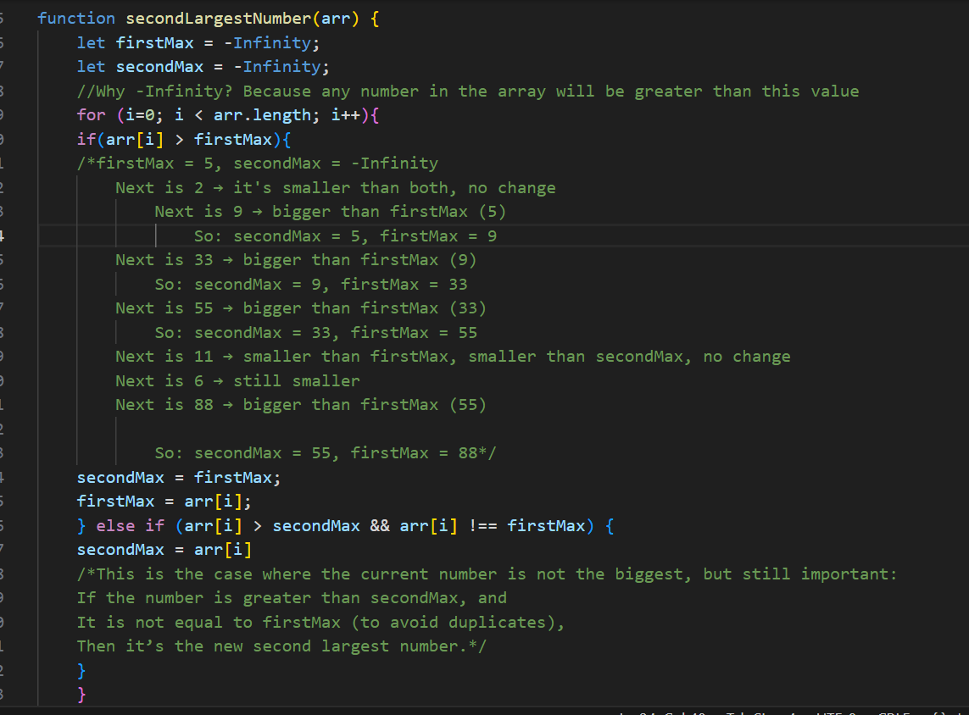
Find the first number greater than 50
Using find method we can achieve.
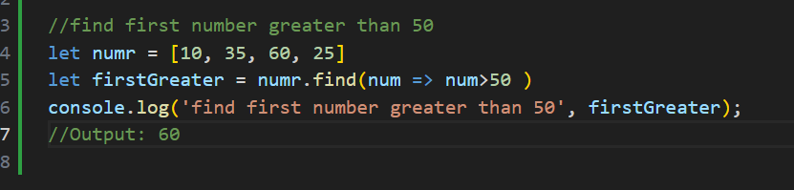

Sum all numbers in the array
array.reduce((accumulator, currentValue) => { ... }, initialValue);
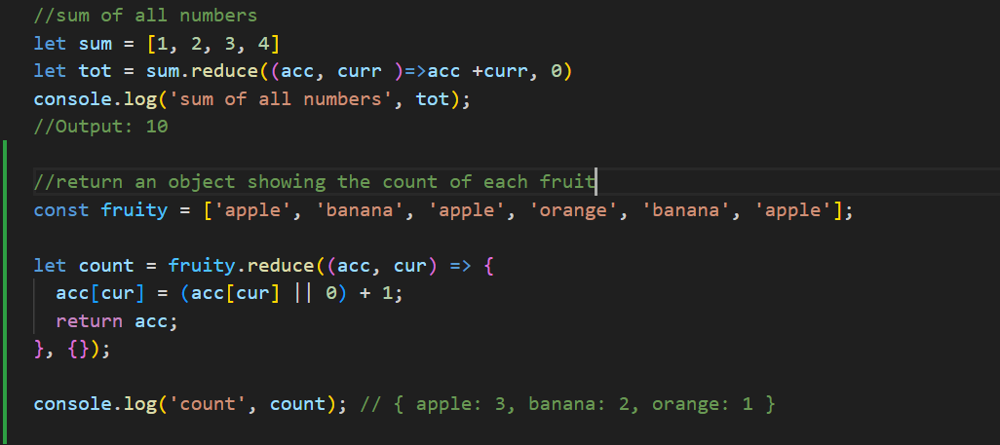
Remove duplicates from an array
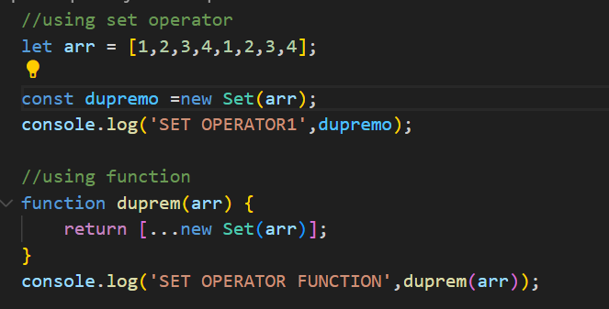
Flatten a nested array
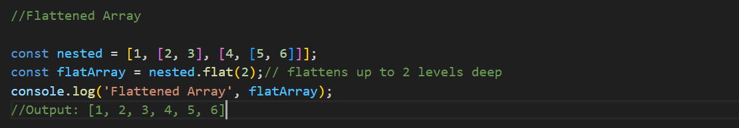
Convert an array to a comma-separated string
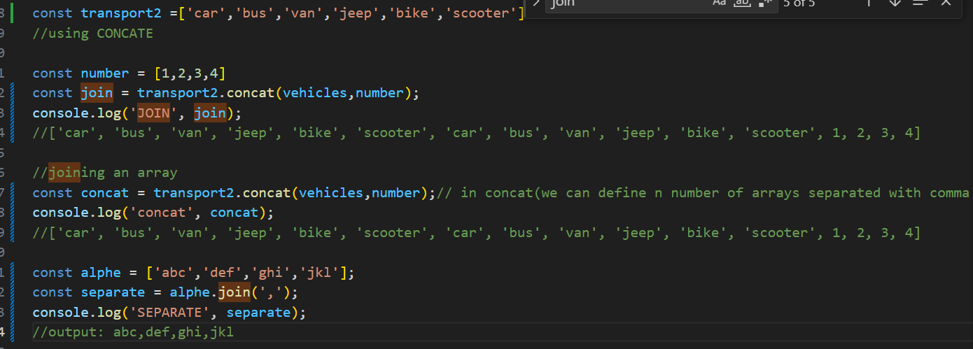
Sort numbers in Ascending/Descending order
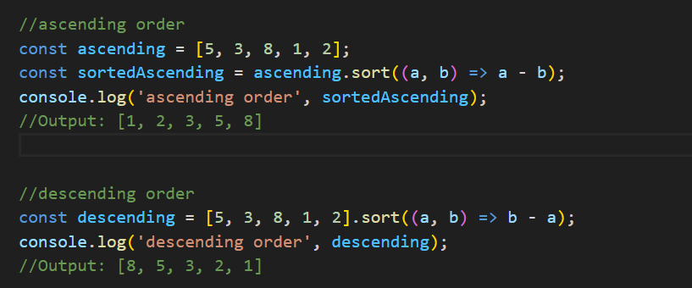
Get names of users who are older than 30 in uppercase.
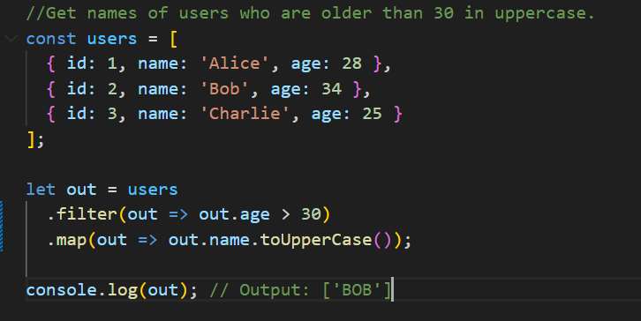
Find the first user who is younger than 30.
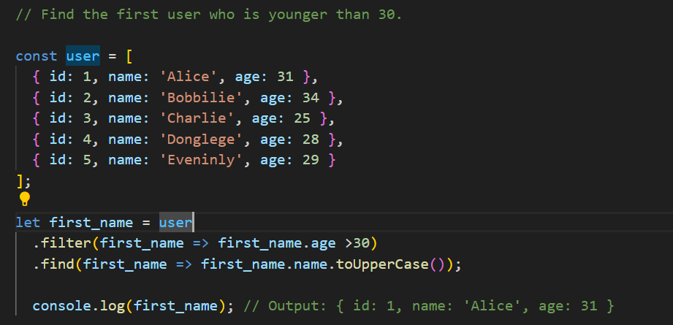
Double the values in an array
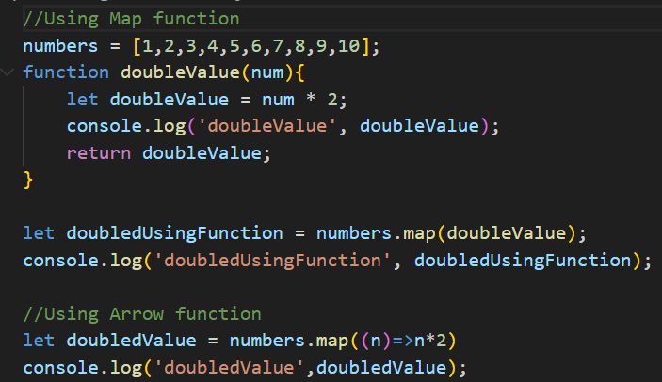
Group an array of objects by a specific property
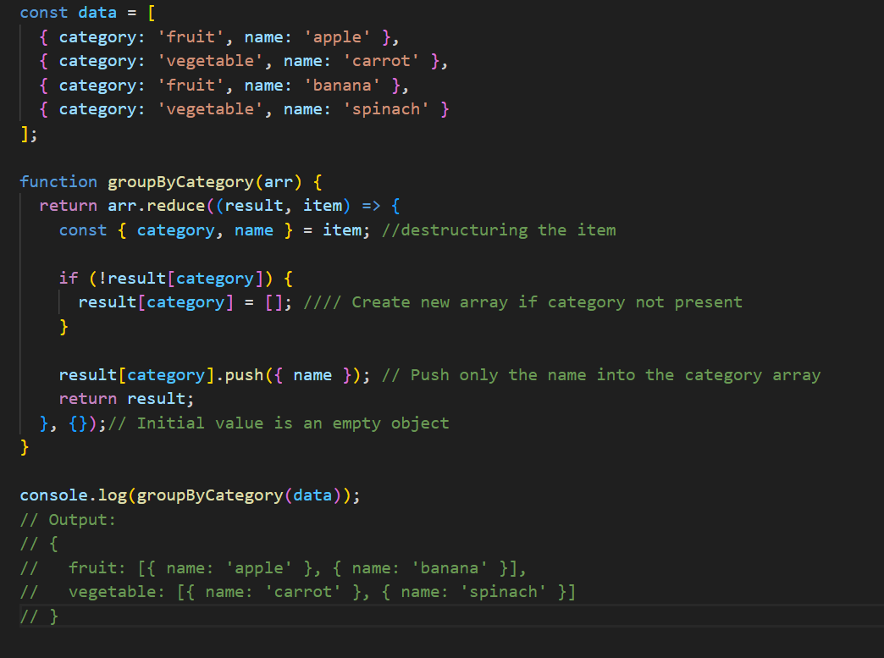

event listener
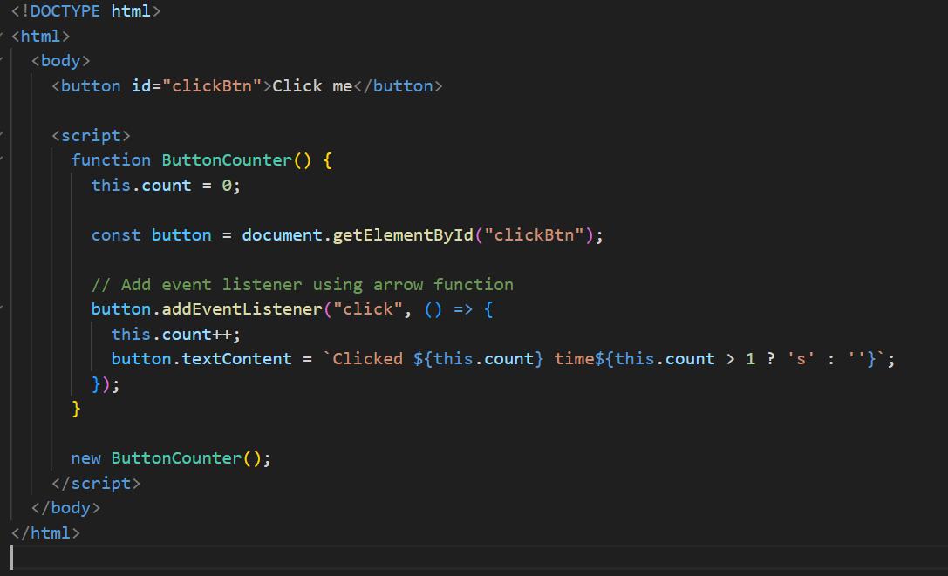
DataTypes
What's the difference between == and === in JavaScript?
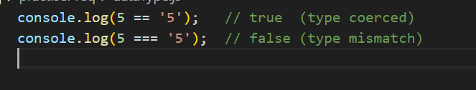
== checks for value equality with type coercion, whereas === checks for both value and type without coercion. For clean, predictable comparisons, prefer ===.
What do you think the output is for:
First
console.log(a); // undefined
var a = 10;
console.log(b); // ReferenceError: Cannot access 'b' before initialization
let b = 20;

NEXT
[] == false //true
[] === false //false
typeof [] is "object" and typeof false is "boolean"
[] == false is true because JavaScript performs type coercion: an empty array converts to an empty string, which becomes false. But [] === false is false because their types differ — object vs boolean.
NEXT
console.log(NaN === NaN); // false
console.log(Object.is(NaN, NaN)); // true
in JavaScript, NaN is not equal to itself with ===, which can be confusing. Object.is() is introduced to correctly compare edge cases like NaN === NaN, and also distinguish +0 and -0.
NEXT
console.log({} == {}); // ? false because creates a new object in memory.
console.log([] == []); // false because creates a new array in memory.
console.log([1] == [1]); // false because creates a new array with one element 1

NEXT
console.log({} + {}); // [object Object][object Object]
console.log([] + []); // empty string
console.log([1] + [1]); // "11"
console.log([] + {}); // [object Object]
console.log({} + []); // 0

NEXT
console.log(0.1 + 0.2 === 0.3); // false
Due to floating-point precision issues, the result of 0.1 + 0.2 is:
To fix Number((0.1 + 0.2).toFixed(2)) === 0.3 // true
NEXT
function test() {
console.log(a);//undefined due to hoisting.
var a = 10;
}
test();

NEXT
!!"false" and !!"true" "false" and "true" are both non-empty strings. •
Any non-empty string in JavaScript is considered truthy.
NEXT
true && "Hello" // "Hello" and operand so it return second value bcz 1st truthy
false && "Hello" // false
false || "Hi" // "Hi" or operand so it will return true or first value
"Hello" || "Hi" // "Hello" or operand so it will return true or first value
!true // false
!0 // true (0 is falsy)

breakdown
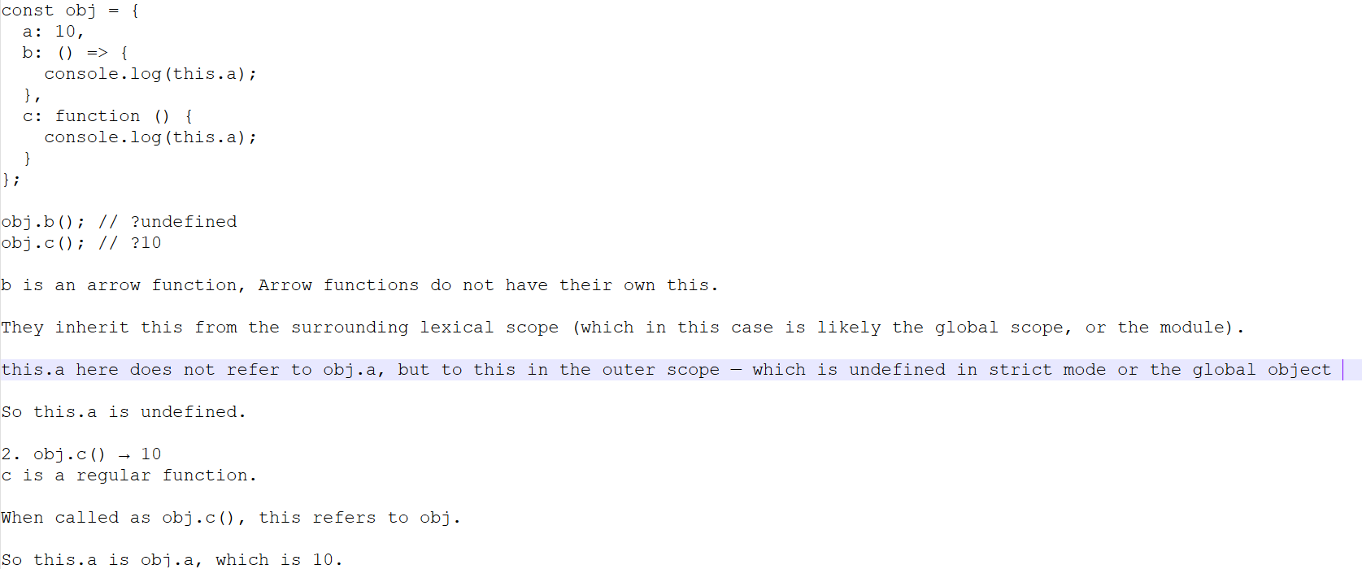
NEXT
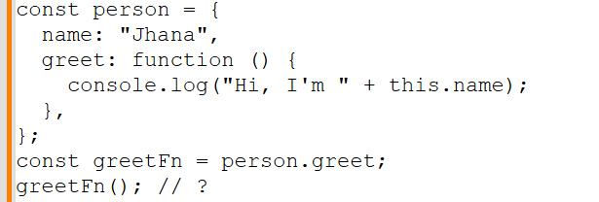
Answer:
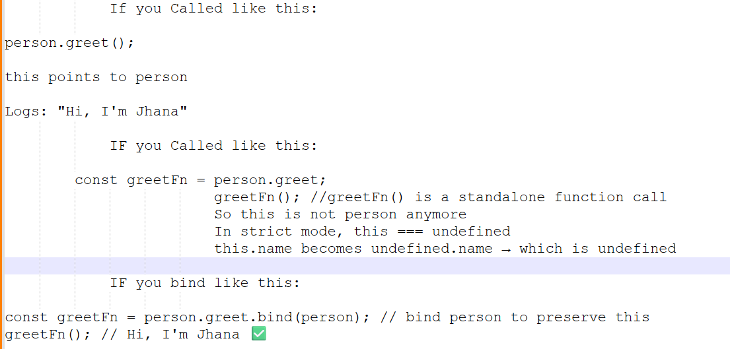
NEXT
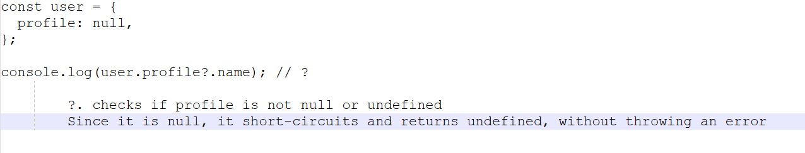
NEXT
greet(); // ❓
var greet = function () {
console.log("Hello!");
}; // it will throw a Type Error because function expression won’t support hoist
NEXT
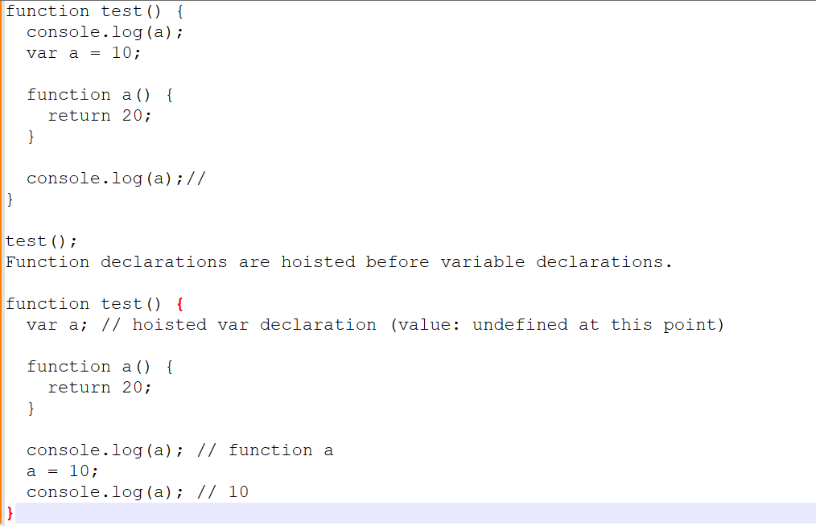
NEXT

let a = [1, 2, 3];
let b = a;
b.push(4);
console.log(a); // [1,2,3,4]
console.log(b); // [1,2,3,4]
object comparison and memory reference
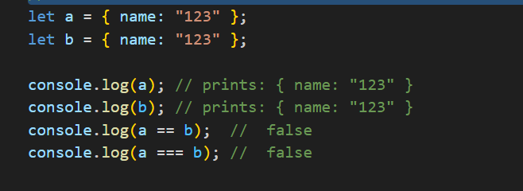
Objects are compared by reference, not by value.
Even if two objects have identical properties and values, if they are created separately, they are stored at different memory locations.
Quick Challenge with object
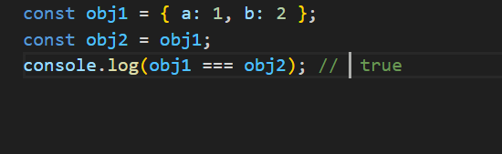
obj2 is not a new object.
It is just a reference to the same object in memory that obj1 points to.
Quick Challenge with array
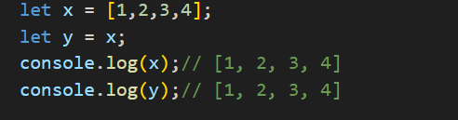
because y is just a reference to the same array x
Need not to change p value.
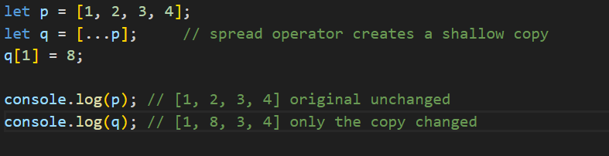
Just recap
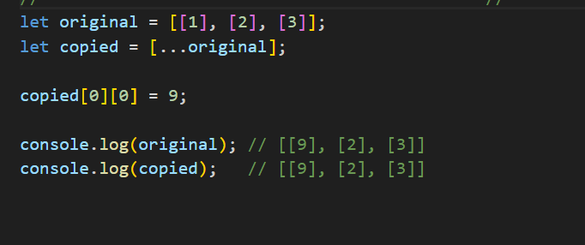
Even though we used the spread operator ([...]) to copy the array, it was a shallow copy, not a deep copy.
copied is a new outer array — ✅ new reference
But each inner element (like [1], [2], [3]) is still a reference to the same inner array in memory
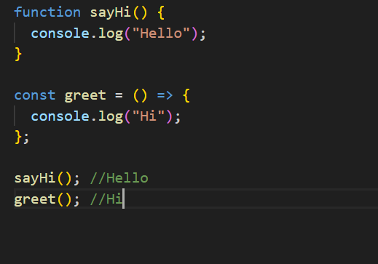
sayHi() is a regular function (hoisted)
greet() is an arrow function (must be declared before calling, and it is)
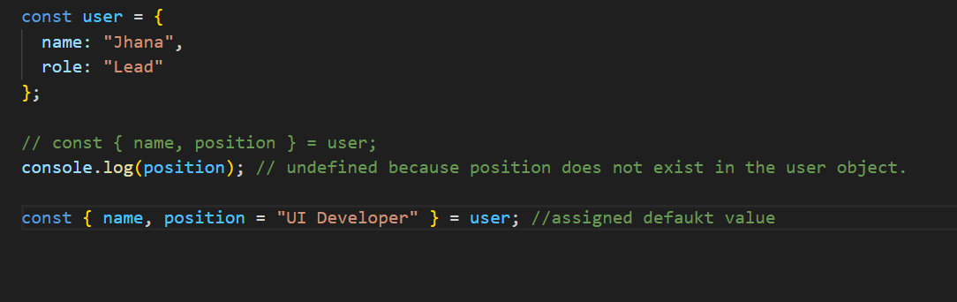
Write a describe User function that takes a user object:
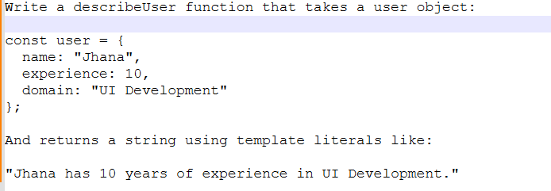
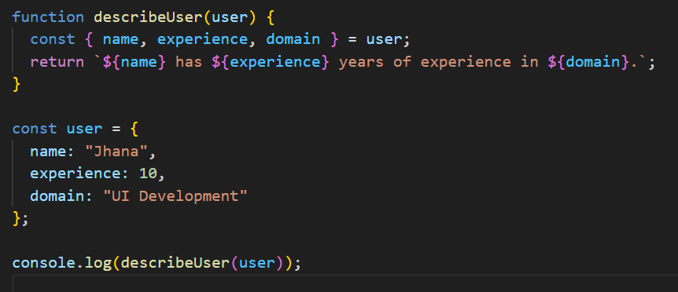
Using Map
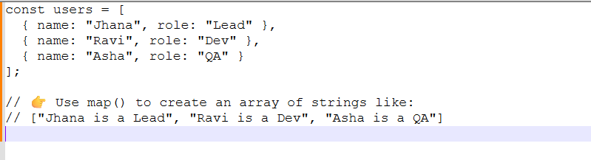
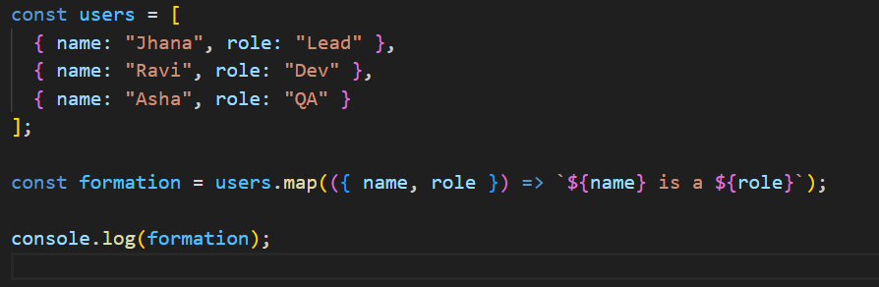
Coding’s with filter concept
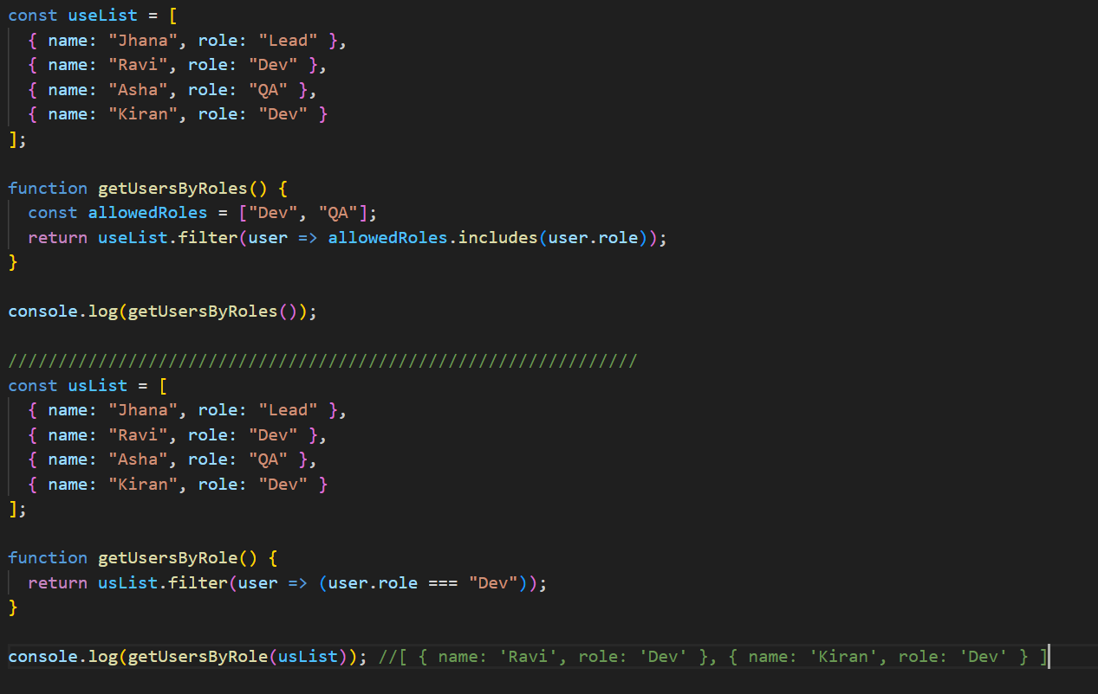

Mastering Array Methods
- How would you create polyfills for common array methods like map, filter, reduce, and forEach?
- What is the difference between splice and slice in JavaScript?
- How would you implement the Array.prototype.flat method in JavaScript?
- How do higher-order array functions improve the readability and functionality of your code?
- Can you explain the concept of immutability when working with arrays?

Function Prototypes
- How would you implement polyfills for Function.prototype.bind, call, and apply?
- Can you explain prototype inheritance in JavaScript with examples?
- How does the this keyword work in different contexts (global, object, function)?
- What is the difference between prototypal and classical inheritance?
- How does Object.create() work, and how is it used in inheritance?

JavaScript in the Browser
- Can you explain the rendering pipeline in the browser and how JavaScript affects it?
- What is event delegation, and how does it improve performance?
- How do event capturing and bubbling work in the DOM?
- What is the difference between event.preventDefault() and event.stopPropagation()?
- How does requestAnimationFrame() work, and when should you use it?

Optimization Techniques
- How would you implement memoization in JavaScript to optimize performance?
- What is lazy loading, and how does it help improve performance?
- Can you explain code splitting and how it can be implemented in a JavaScript project?
- How do you optimize loops and iterations in JavaScript?
- What strategies can you use to reduce DOM manipulations for better performance?

Object Handling
- What is the difference between deep and shallow copies in JavaScript?
- How would you implement a deep clone function in JavaScript?
- What are the risks of mutating objects and how can immutability be maintained?
- How do you handle circular references in deep cloning?
- What are some best practices for object creation and manipulation?

Timers and Events
- How would you implement a clearAllTimeout() function in JavaScript?
- Can you explain the event loop in JavaScript and how it manages asynchronous operations?
- What is the difference between setTimeout and setInterval, and when would you use each?
- How does debouncing and throttling work with timers?
- What is the difference between microtasks and macrotasks in the context of event handling?

Security in JavaScript
- How do you prevent Cross-Site Scripting (XSS) attacks in JavaScript applications?
- What are the best practices for consuming APIs securely in JavaScript?
- How do you sanitize user inputs to prevent security vulnerabilities?
- What are Content Security Policies (CSP) and how do they protect JavaScript applications?
- How can you protect your application against CSRF (Cross-Site Request Forgery) attacks?

ES6+ Features
- What are the differences between let, const, and var?
- How does destructuring work in JavaScript, and what are its benefits?
- Can you explain template literals and how they differ from traditional string concatenation?
- What are arrow functions, and how do they differ from regular functions?
- How do JavaScript modules work, and what are the benefits of using import and export?

Testing in JavaScript
- How do you write unit tests using Jest or Mocha in JavaScript?
- What is the difference between unit testing and integration testing?
- How does Test-Driven Development (TDD) work, and what are its advantages?
- What are mocking and stubbing in the context of testing?
- How do you test asynchronous code in JavaScript?

Performance Optimization
- What are some techniques for optimizing loops and iterations in JavaScript?
- How do you reduce DOM manipulations to improve performance?
- How do efficient event listeners contribute to performance optimization?
- How do you optimize rendering performance in complex applications?
- What are the best practices for lazy loading resources?

Working with APIs
- How does the Fetch API work, and how do you handle errors?
- What are the advantages of using async/await over traditional promise chaining when handling asynchronous data?
- How do you parse and handle JSON responses from an API?
- What are some common issues with CORS (Cross-Origin Resource Sharing), and how do you handle them?
- How do you manage API rate limits and retries in JavaScript?

Package Management
- What is the difference between NPM and Yarn, and when should you use each?
- How does semantic versioning work, and why is it important in package management?
- What are the best practices for managing dependencies in a JavaScript project?
- How do you update dependencies while ensuring compatibility?
- How do you handle peer dependencies in a package?

Debugging Techniques
- What are the different console methods available in JavaScript, and how do you use them for debugging?
- How do you debug JavaScript code using Chrome DevTools?
- What are breakpoints, and how do you use them effectively in debugging?
- What are some best practices for handling and logging errors in JavaScript?
- How do you trace asynchronous code execution during debugging?

JavaScript and CSS
- What are CSS-in-JS libraries, and how do they integrate with JavaScript?
- How do you manipulate styles using JavaScript?
- How do you ensure responsive design using JavaScript?
- How does window.matchMedia work, and how do you use it to handle media queries in JavaScript?
- What are the pros and cons of using inline styles versus external stylesheets in JavaScript projects?

Build Tools
- How do you configure Webpack for a JavaScript project?
- What is Babel, and why is it important in modern JavaScript development?
- How do you set up ESLint and Prettier for consistent code formatting?
- What are the benefits of using source maps in debugging?
- How do you optimize build processes for performance in large projects?

Iterators and Generators
- How would you implement an iterator in JavaScript?
- What are generators, and how do they differ from regular functions?
- How do you use generators for lazy evaluation in JavaScript?
- What are async generators, and when would you use them?
- How do you combine iterators and generators for complex data processing tasks?

